ASSIGNMENT 7

1) Write a query that counts all orders for October 3.

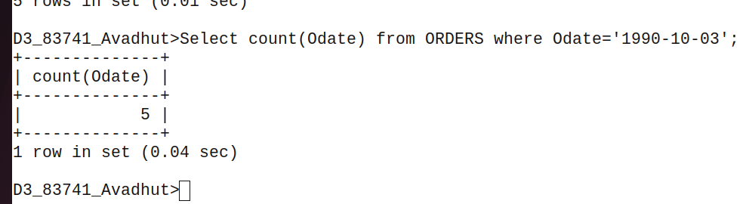
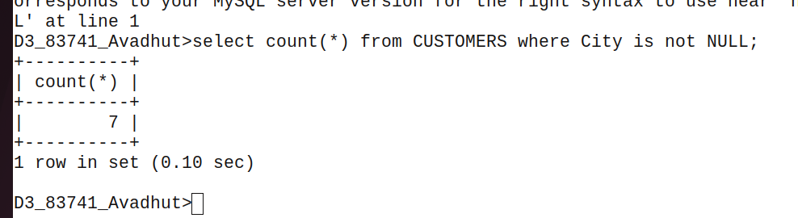
2) Write a query that counts the number of different non-NULL city values in the Customers table.

3) Write a query that selects each customer’s smallest order.
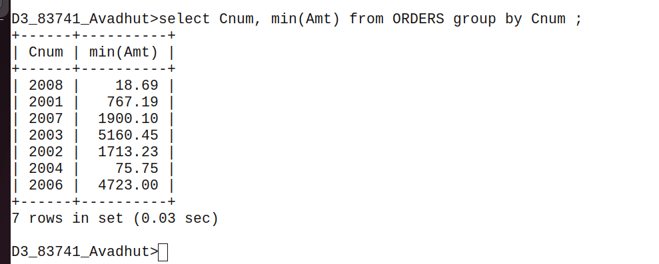
4) Write a query that selects the first customer, in alphabetical order, whose name begins with G.

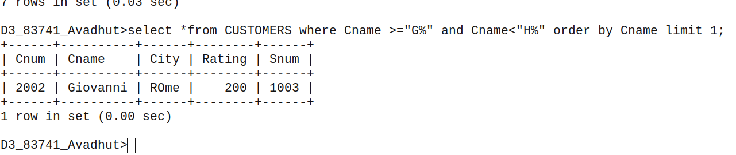
5) Write a query that selects the highest rating in each city.
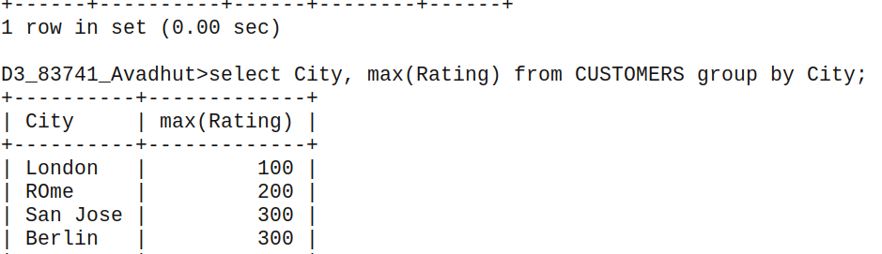
6) Write a query that counts the number of salespeople registering orders for each day. (If a salesperson has more than one order on a givenday,
he or she should be counted only once.).
